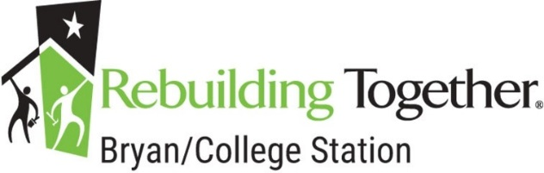
Community Center
Improvement Nomination Form

Name of Nominating Person: __
Phone: _________________________________ Email: ____
Name Community Center Renovated: -----------------------------------------------------_

Address: --------------------------------------------------------------------------------_
City: State: Zip: _________
Does the contact person have decision-making authority for this Facility? Yes / No

Brief Work Description

What are the proposed improvements the Community Center? Please list improvements in order of importance, and whether or not you consider the work to be extensive. This will help RTBCS get an idea of your proposed project.

Is it possible volunteers and friends can help with improvements? Yes / No

If no, please explain why?

Can your facility be closed for renovation over a weekend? Yes / No

Please mail or fax this completed application and all additional requested information to:

Rebuilding Together Bryan / College Station
P.O. 15484
College Station, Texas 77841
Tel: (979) 676-5300

Thank You for your interest in Rebuilding Together Bryan / College Station!

